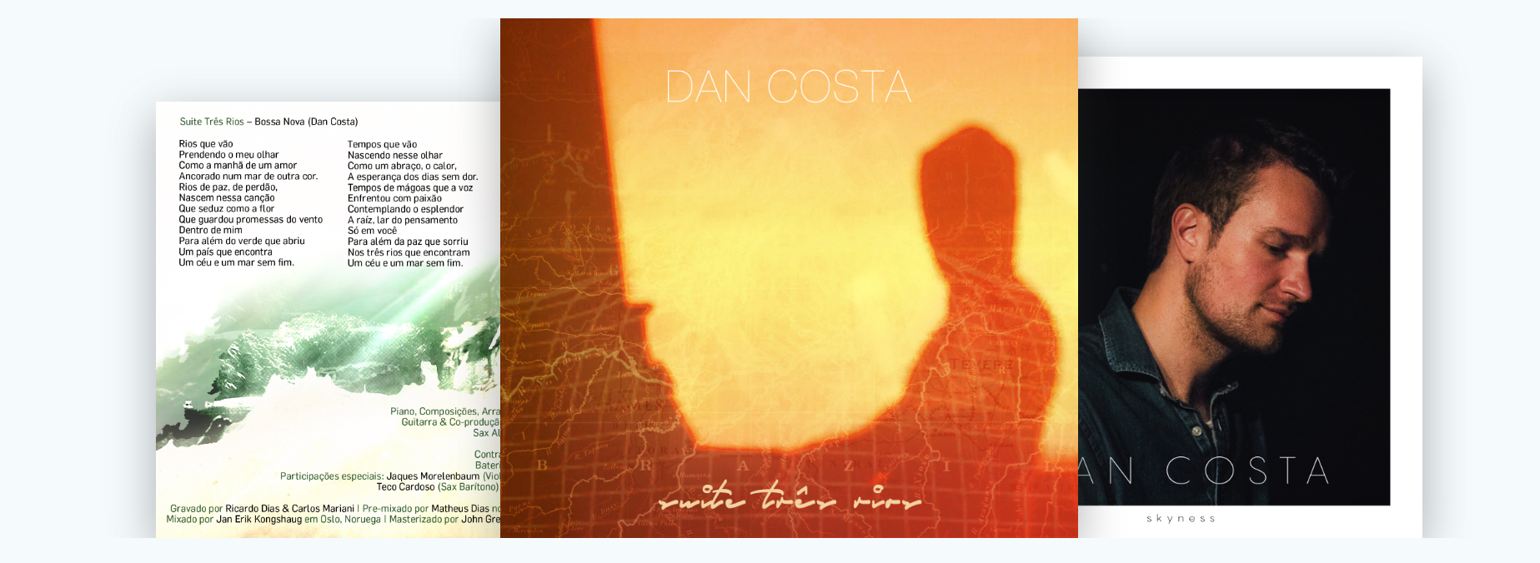
Following his critically-acclaimed debut album “Suite Três Rios”, Dan Costa records “Skyness” at Arte Suono studios in Italy, an invitation to outer harmony and inner peace. It features sax player Seamus Blake, flute player Teco Cardoso, bassist Jorge Helder and Portuguese guitarist Custodio Castelo as well as guitarists Nelson Faria, Romero Lubambo and Bossa Nova icon Roberto Menescal.

The album takes the listener on a journey inspired by the sky and its unifying strength, embracing styles such as European classical music, American Jazz, Brazilian music, Portuguese Fado and Spanish Flamenco. It also pays homage to the idyllic Cycladic islands in Greece where the album was conceived.

"I really enjoyed your musicality, refinement and compositional style. I feel proud to be able to collaborate on this touch of beauty that is given to the world and its people" – Jaques Morelenbaum

"Dan Costa is one of those jazz and bossa nova greats spread all over the world, standing for our good music. It was a pleasure to play with him" – Roberto Menescal

“Melodic and elegant” – Seamus Blake

Bio

Dan Costa's music reflects his cosmopolitan life and diverse cultural background as well as his deep appreciation of the natural world. In a recent interview for Rolling Stone Magazine, he compares musical creation with painting, perceiving colours as tones that guide existence. He sees music as an invitation to outer harmony and inner peace.
Daniel Greco Costa, known as Dan Costa, was born in 1989 in London (UK) to an Italian and Portuguese family. He initially studied classical piano for six years at the Académie de Musique Rainier III in the south of France, as well as jazz. In 2010, he was awarded a diploma with merit at Sir Paul McCartney’s Liverpool Institute for Performing Arts in the UK, but his strong interest in his Latin roots coupled with his passion for jazz led him to study at the Escola Superior de Música e Artes do Espectáculo in Portugal, where he graduated in jazz piano with an award for outstanding achievement, bestowed upon him by Rotary Club Porto-Foz in 2015. During his course, he was also awarded a merit grant to study Brazilian music at UNICAMP – Universidade Estadual de Campinas (São Paulo, Brazil). He pursued further studies at Berklee College of Music.
He has attended workshops and classes given by musical artists such as Gary Burton, Kevin Hays, Scott Colley, Kurt Rosenwinkel, Jorge Rossy, Chick Corea and César Camargo Mariano. He has co-directed musicals, performed with orchestras and big bands, and starred as both a pianist and composer in projects in countries such as the UK, France, Finland, Germany, Spain, Greece and the USA.
In January 2016, he recorded his debut album “Suite Três Rios” in Rio de Janeiro, Brazil, with musicians such as Jaques Morelenbaum, Ricardo Silveira, Teco Cardoso, Rafael Barata, Marcos Suzano and Leila Pinheiro. It peaked at #1 on the iTunes Jazz Chart and Top 10 across all genres in Portugal, prior to hitting the #1 slot on the CMJ Top Adds Chart in the USA and being top 10 for several weeks on Roots Music Report. One of the best albums of the year for Down Beat Magazine, it achieved rave reviews from countries such as the USA, Russia, Canada and Brazil.
In May 2018 he recorded his new album "Skyness" at Arte Suono in Italy, featuring Roberto Menescal, Jorge Helder, Teco Cardoso, Custodio Castelo, Romero Lubambo, Nelson Faria and Seamus Blake, released officially at Blue Note Rio in November. The track "Compelling" was featured by JAZZIZ Magazine on their Summer 2019 Album. His tour took him to countries such as Italy, Malta, Greece, Egypt, Turkey, Brazil, Armenia, Cyprus, Portugal, Spain, Lebanon and India, where he was interviewed and featured by Rolling Stone Magazine.

Press

Skyness (2018)
“Uplifting"
Read more at JAZZIZ Magazine
USA

“Some of the finest piano music you might ever hear… deeply gifted"
Read more at World Music Report
Canada

"Life-affirming and finely recorded album"
Read more at Music Web International
UK

"Rare and luxurious"
Read more at All About Jazz
USA

"A remarkable follow-up to a superb first album. Costa is in full command of his art"
Read more at Música Brasileira
Brazil

Suite Três Rios (2018)
"Έτσι το περιεχόμενο της πρώτης του ηχογράφησης φαίνεται να έχει προκύψει με απόλυτα φυσικό τρόπο"
Read more at Music Buzz
Greece
"Costa reveals a deft technique"
Read more at Music Web International
United Kingdom

"Endless sea of excellence.... The album is a winner in every aspect!"
Read more at Música Brasileira
Brazil

"Valeu a espera"
Read more at Globo
Brazil

"Хорошее начало карьеры для талантливого музыканта и композитора!"
Read more at Jazz Quad
Russia

"The thoroughly cosmopolitan, classically trained Costa has delivered a finely crafted album"
Read more at Downbeat
United States of America

"Brazilian jazz ... has fondly remembered its roots as it unabashedly moves forward"
Read more at All About Jazz
United States of America

"Enjoyable and musically exciting"
Read more at CMuse
Canada

"Tasteful and timeless"
Read more at Skope Entertainment
United States of America

Interviews

Rolling Stone Magazine: https://rollingstoneindia.com/italian-portuguese-pianist-dan-costa-kicks-off-india-tour-week/

Radio Monte-Carlo: https://www.radiomontecarlo.net/video/monte-carlo-nights/248223/dan-costa-ospite-di-monte-carlo-nights.html

Bookings: dancostamusic@gmail.com
Facebook: dancostamusic
Instagram: dancostamusic

