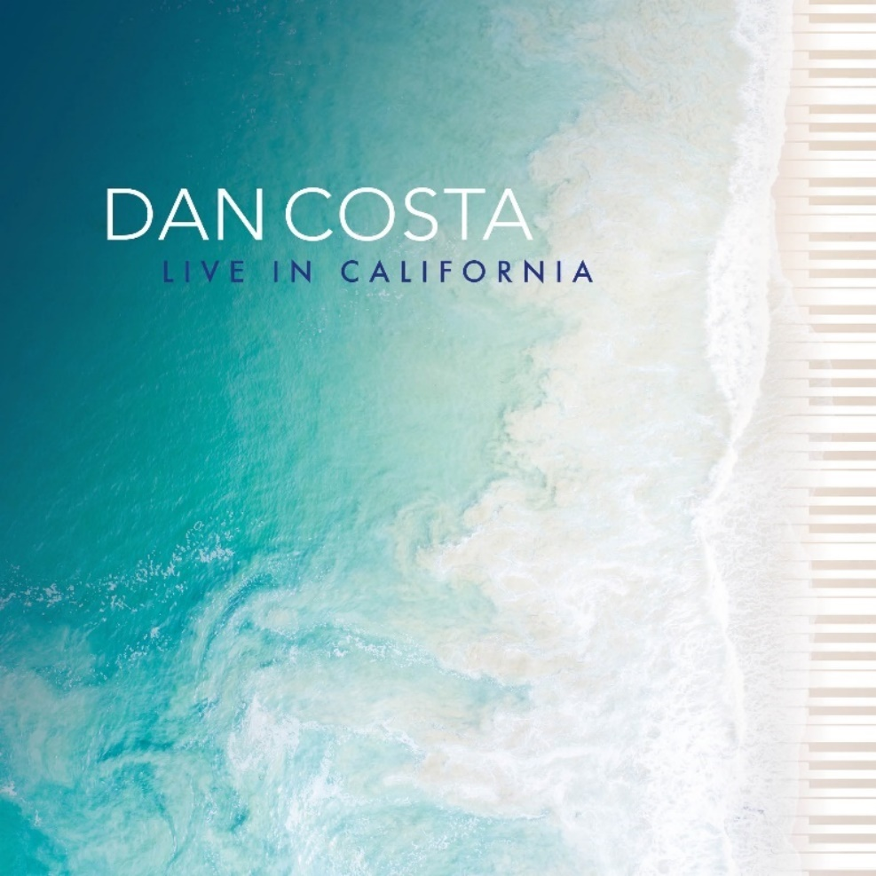
Album cover by Marcilio Godoy

Following two critically-acclaimed studio albums, Dan Costa presents “Live in California”, his first live and solo piano album. It recaptures the intimate setting of the concert, which marked the final stage of his international tour. The album features solo piano versions of previously-released tunes written by Costa and well-known standards by Brazilian jazz legends.

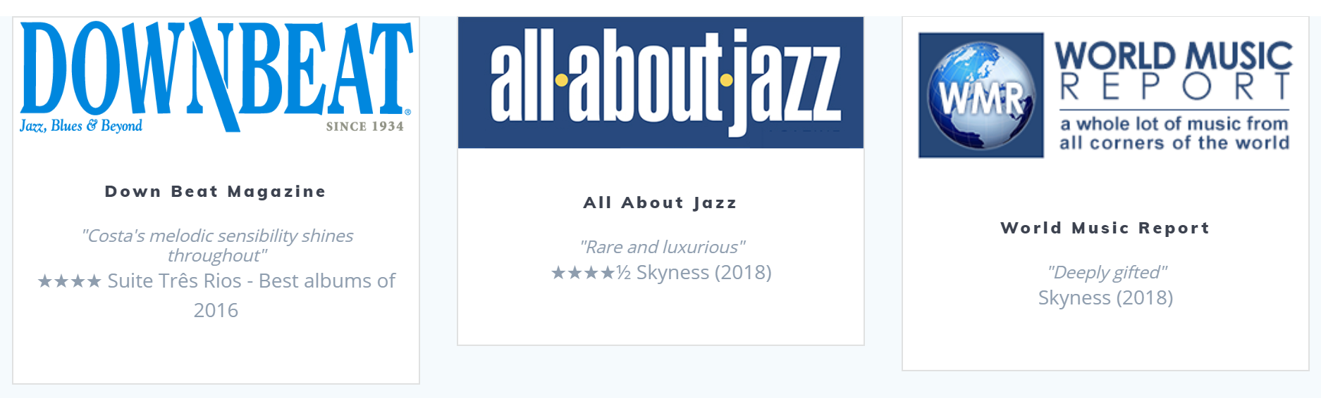

Daniel Greco Costa was born in 1989 in London (UK) to an Italian and Portuguese family. He initially studied classical piano for six years at the Académie de Musique Rainier III in the south of France, as well as jazz. In 2010, he was awarded a diploma with merit at Sir Paul McCartney’s Liverpool Institute for Performing Arts in the UK, but his strong interest in his Latin roots coupled with his passion for jazz led him to study at the Escola Superior de Música e Artes do Espectáculo in Portugal, where he graduated in jazz piano with an award for outstanding achievement, bestowed upon him by Rotary Club Porto-Foz in 2015. During his course, he was also awarded a merit grant to study Brazilian music at UNICAMP – Universidade Estadual de Campinas (São Paulo, Brazil). He pursued studies further studies at Berklee College of Music with a scholarship for outstanding achievement.

He has attended workshops and classes given by musical artists such as Gary Burton, Kevin Hays, Scott Colley, Kurt Rosenwinkel, Jorge Rossy, Chick Corea and César Camargo Mariano. He has co-directed musicals, performed with orchestras and big bands, and starred as both a pianist and composer in projects in countries such as the UK, France, Finland, Germany, Spain, Greece and the USA.

In January 2016, he recorded his debut album “Suite Três Rios” in Rio de Janeiro, Brazil, with musicians such as Jaques Morelenbaum, Ricardo Silveira, Teco Cardoso, Rafael Barata, Marcos Suzano and Leila Pinheiro. It peaked at #1 on the iTunes Jazz Chart and Top 10 across all genres in Portugal, prior to hitting the #1 slot on the CMJ Top Adds Chart in the USA and being top 10 for several weeks on Roots Music Report. One of the best albums of the year for Down Beat Magazine, it achieved rave reviews from countries such as the USA, Russia, Canada and Brazil.
In May 2018 he recorded his new album "Skyness" at Arte Suono in Italy, featuring Roberto Menescal, Jorge Helder, Teco Cardoso, Custodio Castelo, Romero Lubambo, Nelson Faria and Seamus Blake, released officially at Blue Note Rio in November. The track "Compelling" was featured by JAZZIZ Magazine on their Summer 2019 Album. His tour took him to countries such as Italy, Malta, Greece, Egypt, Turkey, Brazil, Armenia, Cyprus, Portugal, Spain, Lebanon and India, where he was interviewed and featured by Rolling Stone Magazine. In 2020, he recorded with Brazilian legend Ivan Lins and released his first live and solo piano album.

"Realmente gostei da sua musicalidade, apuro e estilo de composição. Sinto-me orgulhoso de poder colaborar nesta pitada de beleza que aqui se dá ao mundo e às suas pessoas" - Jaques Morelenbaum
"I really enjoyed your musicality, refinement and compositional style. I feel proud to be able to collaborate on this touch of beauty that is given to the world and its people"

"Dan Costa é um desses craques do jazz e da bossa nova espalhados pelo mundo, defendendo nossa boa música. Foi um grande prazer tocar com ele" - Roberto Menescal
"Dan Costa is one of those jazz and bossa nova greats spread all over the world, standing for our good music. It was a pleasure to play with him"

"Melodic and elegant" - Seamus Blake

"Bem bonita sua música Dan" - Leila Pinheiro
"Beautiful Music Dan"

"Uma sonoridade doce, de rara beleza, translúcida, uma técnica fluida que nunca se impõe à narrativa musical ... poesia tão necessária para apaziguar
os dias turbulentos em que vivemos" - André Mehmari
"A sweet, beautiful, translucent sound of rare beauty and a technical fluidity that never hinders the musical narrative... extremely necessary poetry to calm down the turbulent days we are living"

"Parabéns pelo bom gosto nos solos de piano e composições avançadas" - Toninho Horta
"Congratulations for your good taste in piano soloing and for your advanced compositions"

Facebook: dancostamusic
Instagram: dancostamusic
Soundcloud: dancostamusic
Spotify: https://open.spotify.com/artist/6CYdkCOXw3fRHUc2BxciuE?si=_kFfQ6rySMSPwtfva-I7KA
Youtube: https://www.youtube.com/channel/UCDgHGqZNBS_kjyz-ZdUfviA

